How to Add/Edit Signatures in Outlook 2016

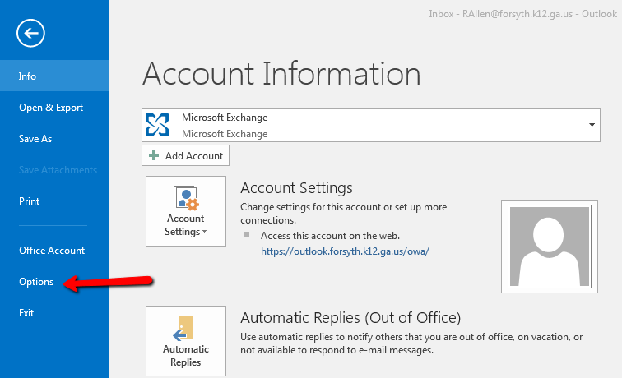
- Open Microsoft Outlook 2016, click on the File menu and select Options.

- In the pop-up window, select Mail.
- Then, click the Signatures… button.
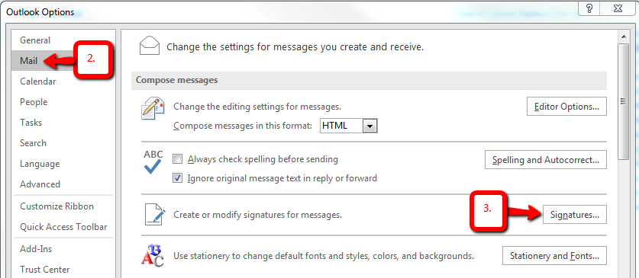

- In the Signatures and Stationery window, find the Select signature to edit box and click on mysignature. (If mysignature is not in the list of signatures to edit, click New and name the signature mysignature.)
  - In the Edit Signature box, type your signature as you wish it to appear on your emails.
  - In the Choose default signature section, select mysignature in the New messages drop down list and in the Replies/forwards drop down list.
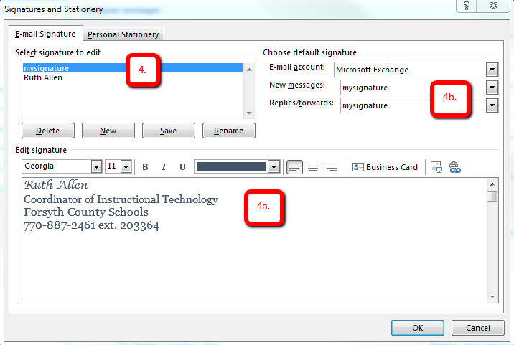

- After editing the signature, click OK. Click OK to close Outlook window.

Other Recommended Setting Changes in Outlook 2016

      - Set Outlook to automatically empty deleted items folder when you exit:
  - In Outlook 2016, click on the File menu, select Options, and then in the Outlook Options window, select Advanced (in the left column).
  - Put a check in the box next to Empty Deleted Items folder upon exiting Outlook.
  - Click OK.
